# Data Structures and Algorithms(UCS540)

Sixth-Semester

Submitted by:

Naman Sood [102104012] 3EE2

BE Third Year (2021-2025) Electrical Engineering

Submitted To: Dr. Yadvendra Singh

Assistant Professor



Department of Electrical & Instrumentation Engineering,

Thapar Institute of Engineering & Technology, Patiala

January-May 2024

# List of Experiments

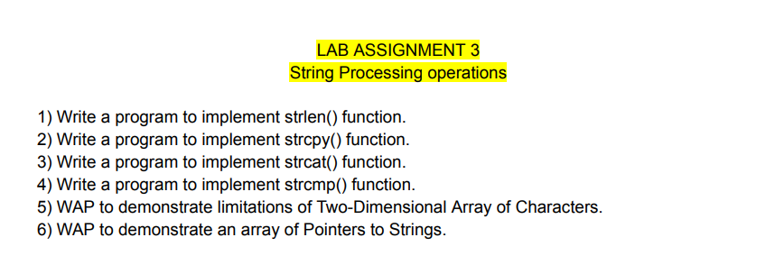

**Q1.**

#include <iostream>

using namespace std;

#include<string.h>

int main ()

{

char str1[]="Hello Geeks!";

cout<<"Length of string "<<"'"<<str1<<"'"<<" is "<<strlen(str1);

return 0;

}

**Output:**

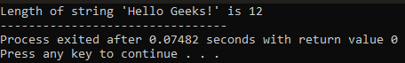

**Q2.**

#include <iostream>

using namespace std;

#include<string.h>

int main ()

{

char str1[]="Hello Geeks!";

char str2[] = "GeeksforGeeks";

char str3[40];

char str4[40];

char str5[] = "GfG";

strcpy(str2, str1);

strcpy(str3, "Copy successful");

strcpy(str4, str5);

cout << "str1: " << str1 << "\nstr2: " << str2 <<"\nstr3: "<< str3 << "\nstr4: "<< str4;

return 0;

}

**Output:**

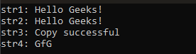

**Q3.**

#include<iostream>

#include<string.h>

using namespace std;

int main()

{

char str1[100] = "Data Structures";

char str2[] = " and Algorithms";

cout<<"\nBefore Concatenation:\n"<<"str1:"<<str1<<"\nstr2:"<<str2<<"\n"<<endl;

strcat(str1,str2);

cout<<"After Concatenation:\n"<<"str1:"<<str1<<"\nstr2:"<<str2<<"\n"<<endl;

char* final = strcat(str1,str2);

cout<<"After Concatenation:\n"<<final<<endl;

return 0;

}

**Output:**

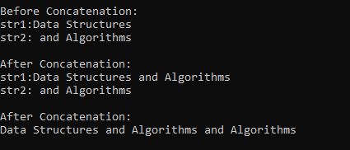

**Q4.**

#include <iostream>

using namespace std;

#include <string.h>

int main() {

char str1[] = "abcd", str2[] = "abCd", str3[] = "abcd";

int result;

result = strcmp(str1, str2);

cout<<"strcmp(str1, str2) = "<<result<<endl;

int result1;

result1 = strcmp(str2,str1);

cout<<"strcmp(str2,str1) = "<<result1<<endl;

int result2;

result2 = strcmp(str1, str3);

cout<<"strcmp(str1,str3) = "<<result2<<endl;

return 0;

}

**Output:**



**Q5.**

#include <iostream>

using namespace std;

int main() {

const int rows = 3;

const int columns = 5;

char charArray[rows][columns] = {

{'A', 'B', 'C', 'D', 'E'},

{'F', 'G', 'H', 'I', 'J'},

{'K', 'L', 'M', 'N', 'O'}

};

// Display the original array

std::cout << "Original 2D Array of Characters:" << std::endl;

for (int i = 0; i < rows; ++i) {

for (int j = 0; j < columns; ++j) {

cout << charArray[i][j] << " ";

}

cout << endl;

}

cout<<endl;

// Limitation 1: Fixed size

// You cannot change the size of the array at runtime

// Error

/*

const int newRows = 4;

const int newColumns = 6;

charArray = new char[newRows][newColumns];

*/

return 0;

}

**Output:**

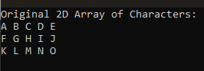

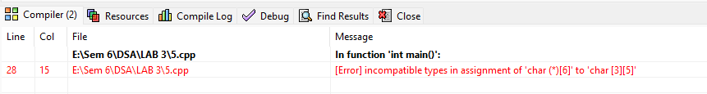

**Q6.**

#include<iostream>

using namespace std;

#include<string.h>

int main()

{

const char* string1[] = {"LAB "};

const char* string2[] = {"ASSIGNMENT "};

const char* string3[] = {"- 3"};

// char arr[] = {'L','A','B',' ','A','S','S','I','G','N','M','E','N','T',' ','-',' ','3'};

const char** arr1[] = {string1,string2,string3};

for(int i = 0; i < sizeof(*arr1); i++)

{

cout << (**(arr1+i)) ;

}

return 0;

}

**Output:**

